Ryan Ho Hip

St10440709

XHAW5112

POE

Contents

Empowering the nation 3

Project Outline 4

Declaration of Authenticity 9

# Empowering the nation

Group members:  
Molemo (leader)

Callon (Project Manager)

Ryan (Project Manager)

# Project Outline

The name of the business is “Empowering the nation” and the owner leading the business is Precious Radebe. The business is about skills and development training dedicated domestic workers and gardeners. The business offers a variety of courses and to allow this business to grow further, the recommendation of creating a web page and mobile app will allow the business to be more interactive with their customers by allowing the streamlining of course selection and enrolment.

Empowering the Nation was established in 2018 and offers courses in Johannesburg. Hundreds of domestic workers and gardeners have been trained on both the six-month long Learnerships and six-week Short Skills Training Programmes to empower themselves and can provide more marketable skills. The six-month programmes take place over 12 weeks and the short courses take six weeks.

The main goals of the website and mobile application are to advertise the business, to accept information requests, to provide quotes based on courses that customers have chosen, to facilitate course enrolment so that users can choose and enrol in courses directly through the platforms, and to apply discounts based on the quantity of courses chosen.

A home page with the organization's objective and logo, course summaries for six weeks and six months, comprehensive pages for each course, and a price calculating tool with automatic discount application are some of the main features. There will be a wealth of contact information available, including phone numbers, email addresses, physical addresses, and map locations. First Aid, Sewing, Landscaping, Life Skills, Childminding, Cooking, and Garden Maintenance are among the courses available; each has a different cost and curriculum. Strong error handling, a drop-down menu, and a "return to previous screen" option are further needs. Precious Radebe's goal will be supported by this digital change, which will make skill training more convenient and accessible, empowering local gardeners and domestic staff. The choice of this design was made to ensure a smooth user experience by making it both easy to understand and informative. Users can easily and quickly find the information they need by concentrating on the presentation of clear and concise information. Users can easily navigate the sites and make use of the capabilities thanks to the user-friendly interface and simple navigation, which lowers the learning curve. By making it easy for users to access course summaries, comprehensive information, and price calculations, this strategy puts a priority on user happiness and improves their overall engagement and involvement with the platform.

Wireframes

Home page

Course details:

Calculate total fees:

Logo

# Declaration of Authenticity

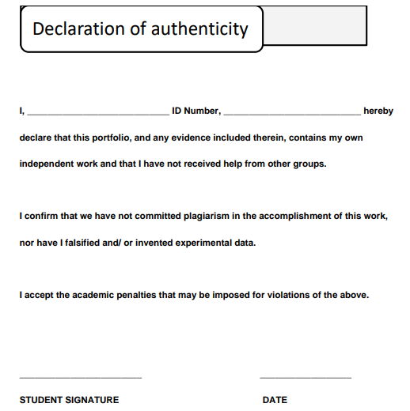

2024/10/16

0501065777085

Ryan Ho Hip

# Self evaluation

**Introduction**  
During my Work-Integrated Learning (WIL) experience, I realized how valuable it is to put classroom knowledge into action. The whole point of WIL is to bridge the gap between theory and practice, helping us grow in both technical and personal skills. Acting as a project manager in our group, I took on responsibilities in app and web development while learning about effective communication, teamwork, and managing professional spaces. I also explored how important it is to stay ethical and conduct myself professionally, both during and outside of working hours.

**Skills Learnt**  
Throughout the project, I picked up quite a few important skills:

*Industry-specific skills:*  
I worked on building apps with Kotlin and developed websites using HTML, CSS, and XML, primarily using Visual Studio Code. Along the way, I had to dive into GitHub for version control, learning how to push code and collaborate with the team. This required a lot of self-research, where I used YouTube tutorials, AI tools, and W3Schools to guide me through unfamiliar coding tasks.

*Interpersonal communication skills:*  
Our group had frequent brainstorming sessions, feedback meetings, and general discussions to make sure we were on the same page. I quickly learned that good communication is key, whether it’s through formal meetings or casual team chats. It was important to express my ideas clearly and ensure everyone understood the project’s goals, especially when conflicts or misunderstandings popped up.

*Management skills:*  
As the project manager, time management became essential. I had to make sure we met deadlines while keeping the project’s quality intact. When we ran into unexpected issues—like difficulty with GitHub or struggles in coding—I had to step in, research solutions, and work with my teammates to solve the problems. This experience taught me how to manage crises and ensure the team stayed on track.

**Role in the Team**  
Our team dynamic was generally smooth, and I took on the role of project manager. I reported to a team lead but was largely responsible for managing my peers. My role involved organizing tasks, assigning responsibilities, and ensuring everyone was aligned with our deadlines. I contributed by guiding my team through challenges, offering support, and making sure conflicts were handled constructively. Leading the team, I felt a strong sense of responsibility, not just for my tasks but for helping my teammates when they faced difficulties.

**Research, Technology, and the Presentation of Information**  
I frequently had to research new concepts to keep the project moving. One of the key scenarios was learning how to push and import repositories from GitHub, which I hadn’t done before. I found most of the information I needed through platforms like YouTube and W3Schools. Once I figured it out, I presented the solution to the team in a clear and structured way, ensuring they could apply the knowledge as well. I also used AI tools for coding assistance and troubleshooting, which made my learning curve easier.

**Personal Strengths and Weaknesses**  
I discovered a few areas where I performed well and others where I struggled:

*Strengths:*

1. *Communication:* I consistently explained my work clearly, especially when it came to CSS and Kotlin XML code. I made sure my team understood the technical aspects I was responsible for.
2. *Leadership:* As a project manager, I ensured tasks were distributed fairly and that the team stayed on track.
3. *Problem-solving:* Whenever we hit a roadblock, I would jump in to research solutions and guide the team forward.
4. *Reliability:* I stayed on top of deadlines and always delivered my work on time, even when challenges arose.
5. *Adaptability:* I picked up new skills quickly, such as learning GitHub and improving my coding knowledge, even though I had to start from scratch in many areas.

*Weaknesses:*  
I found it difficult to work independently on certain coding tasks. As someone new to coding, I often relied on external help to get through parts of the project. This made me realize I still need to build confidence in my coding abilities. I plan to spend more time coding on my own and practicing regularly, so I can work more independently in the future.

**Stakeholder Relationship**  
My relationship with the WIL Coordinator (or mentor) was supportive, but I could have been more proactive in seeking their advice. I tended to wait for feedback instead of reaching out for guidance, which I now see could have made the relationship stronger. In the future, I plan to take more initiative in building professional relationships by being more engaged and seeking regular feedback.

**Impact**  
I believe my role had a positive impact on the team and the project. As the project manager, I made sure the project stayed on course and that everyone contributed effectively. My research and troubleshooting helped the team overcome technical challenges, and I feel that my leadership and communication skills contributed to the overall success of the project.

**Conclusion**  
Overall, my WIL experience was valuable. I not only improved my technical skills in Kotlin, HTML, and GitHub, but I also developed strong communication and leadership abilities. While I faced some challenges, like needing help with coding tasks, I’ve learned valuable lessons that I’ll carry forward. I’m excited to apply what I’ve learned in future projects and continue growing both personally and professionally.

# Peer evaluation

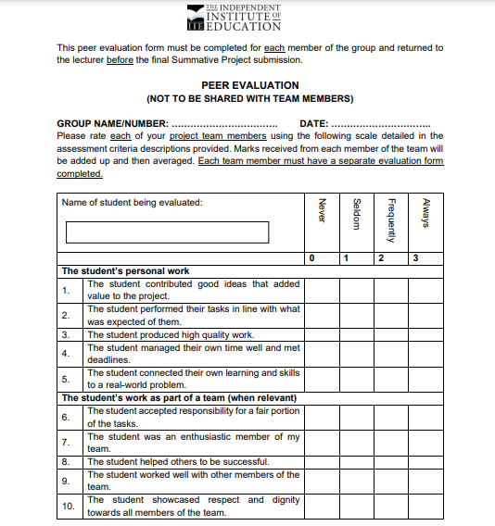

2

Molemo

2024/10/16



Callon

2024/10/16

**2**